**Ques 1:**

Create your own new custom VPC

* And configure your EC2 linux instance inside your custom VPC
* and then create 3 subnets of that VPC
* Attach an internet gateway to your custom VPC

Here’s a screenshot of the custom VPC that I have created,

* I have added two public subnets and a private subnet for RDS.

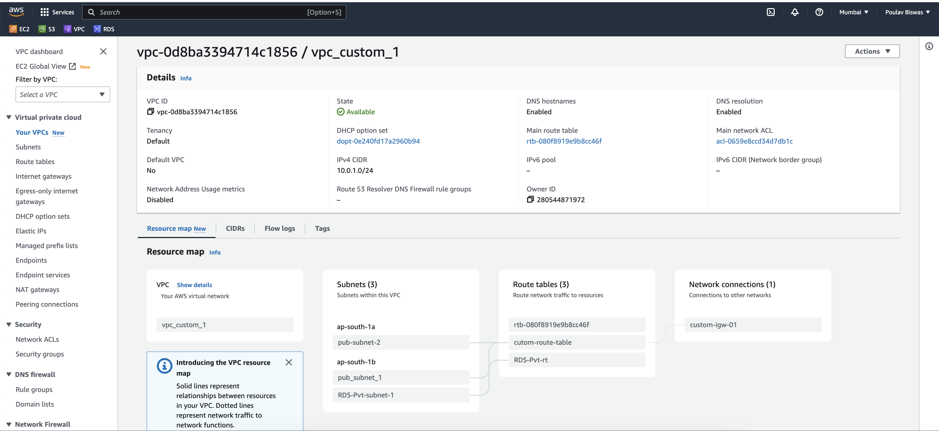

Configuration for pub-subnet-2,

* Here I have configured the route table with internet gateway such that the EC2 instance can be made public.

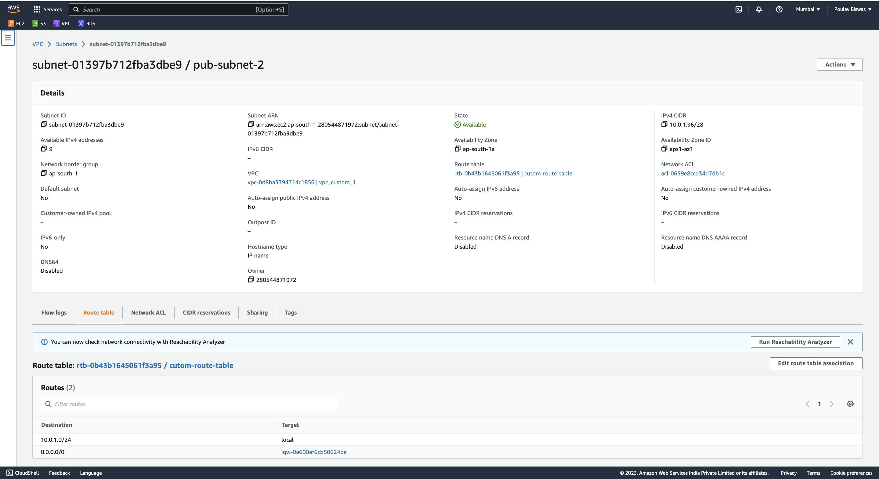

* Below is the configuration for pub_subnet_1 which is same as the previous one.

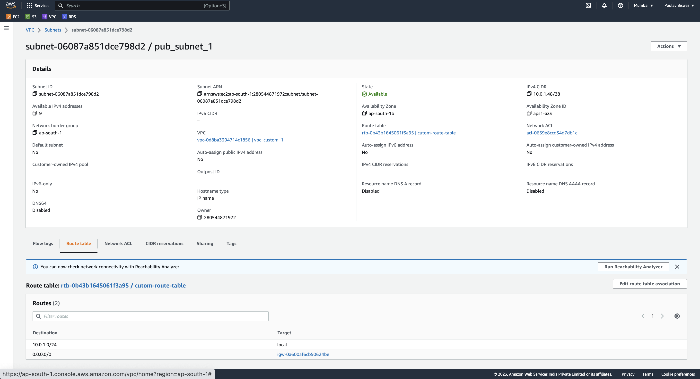

* Here’s the private subnet for RDS, the difference here is there’s no internet gateway connected. It has been done on purpose as database shouldn’t be exposed to the internet.

